The battery is not working - load power is low

Author：胡维
Reviewer：Eason

FAQ\ Hybrid INV
Issue introduction
No battery output when the loads are working with low power
Confirmation of basic information
[Photo] SN numbers of inverters.
[Photo] ‘HotStandby Set’ function should be disabled.
Guidance for installer
Step1: Set HotStandby Disable.
Settings path: Setting→Advanced setting → HotStandby Setting
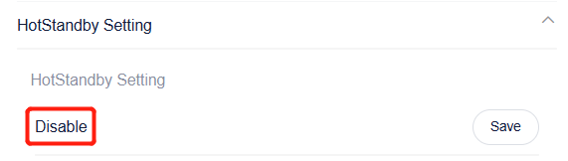
Information check list
If you have completed the above <Guidance for installer>, and the problem is still not solved, please collect the following troubleshooting information and send them to the R&D.
1.[Photo] SN number of the inverter, which should clearly display the registration number.
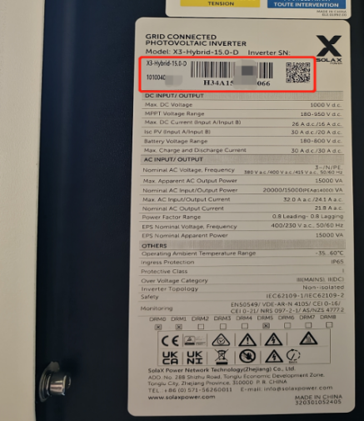
2.[Photo] ‘HotStandby Set’ function should be disabled.

